Unit 9 : Day 0 : Course Summative - Preparation Guidelines |  |  |  |  | Grade 11 U/C
Minds On: 5 min |  |  | Description  Note: this could be a period, part of a class, or done from home.  Students will:  - Be provided with the information needed to engage in the summative activity and feel comfortable with the context.  - Review required skills for using the graphing calculator. |  | Materials  - BLM 9.0.1  - BLM 9.0.2 (will require internet access)  - BLM 9.0.3  - BLM 9.0.4  - LCD projector and internet access (optional)
Action: up to 65 min
Consolidate: 5 min
Assessment
Opportunities
 | Minds On… | Whole Class → Discussion  Activate prior knowledge about tides.  Distribute BLM 9.0.1 or BLM 9.0.2 (requires access to the internet). Explain to students that they will have access to their BLM as a reference for the two days of the assessment. |  |  |  | Note: It may save time if groups are assigned during the summative preparation.  Students will have access to preparation material (BLM 9.0.1 and/or BLM 9.0.2) throughout the two days of the assessment.
 | Action! | Small Groups or Individually → Gathering and Organizing Information  If using BLM 9.0.1 students will read through and discuss in small groups to ensure clarity of main ideas (ideally, in the groups they will be working with on day 1 of the assessment).  If using BLM 9.0.2 students will work through the Treasure Hunt.  Optional: students could spend time working with graphing calculators.  - storing pictures collected from the CBR  - setting up sample collection for CBR  - transferring data (lists) between calculators  - manipulating lists (e.g., copying, creating, deleting)  - using regressions – linear, quadratic, exponential and sinusoidal
 | Consolidate Debrief | Whole Class ➔ Discussion  Follow up discussion around the information acquired.  Teachers collect BLM chosen for this activity and will return to students on each of the days of the assessment.

Home Activity or Further Classroom Consolidation

Teacher could provide website links for further exploration (BLM 9.0.3)

9.0.1 Summative Preparation

What causes tides and tidal currents?
(http://www.nos.noaa.gov/education/kits/tides/lessons/tides_upsanddowns.pdf)

Key Words

Tide Ebb Spring tide
Tidal current Flood Neap tide

Background

Tides are the periodic rising and falling of ocean waters caused by the gravitational forces of the sun and moon. The vertical motion of tides is accompanied by a horizontal movement of ocean waters called tidal currents. Oceanographers say that tides rise and fall, while tidal currents ebb (during a falling tide) and flood (during a rising tide).
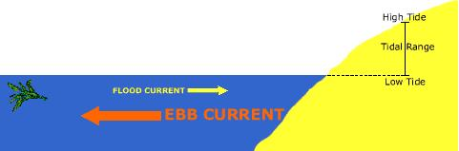
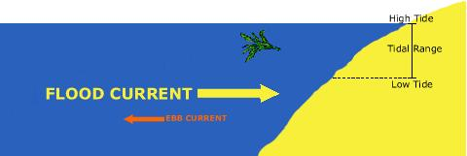

For a simple explanation of tides, it is sufficient to consider only the effects of the moon (the magnitude of the moon’s effect is about twice that of the sun, since the moon is closer to the Earth). At any point in a day, one side of the Earth will be closer to the moon than the opposite side. Ocean waters on the closer side of the Earth will experience a greater gravitational pull from the moon than waters on the opposite side of the earth. This causes a “bulge” in the waters closest to the moon, and creates a high tide. At the same time, inertial forces on the opposite side of the Earth causes a similar “bulge” creating another high tide. Low tides occur at longitudes that are at right angles from the longitudes of locations that are experiencing high tides.

The sun also exerts a gravitational force on ocean waters. Depending upon the positions of the sun and moon relative to the Earth, the sun’s gravity may enhance or diminish the tidal effect caused by the moon.

9.0.2 Tides Treasure Hunt – “surfing” the net

- Go to the website below to access a Treasure Hunt for information about ocean tides. Record your answers below. You will have access to this handout over the next two days.

http://www.nynetresources.org/Future%20Grant%20Projects/Projects/Tides/tideshunt.htm

- What does the word tide mean?
- What is a high tide?

- What is a low tide?

- What two objects in our sky cause ocean tides?

- Which has the greater effect?

- What is a tidal range?

- What is a spring tide?

- What causes a spring tide?

- What is a neap tide?

- What causes a neap tide?

- How long is a tidal cycle?

- How many high tides occur each day?

- How many low tides occur each day?

- Why do the normal number of high and low tides not happen in some places?

- Name one place where this is true, and tell how many high or low tides happen there.

- What is the most interesting thing you learned today about tides?

Use the back of this page to draw any pictures that you may feel are useful to your understanding of tides.

9.0.3 Summative Preparation (Teacher resource material)

Treasure hunt resource link and description
http://www.nynetresources.org/Future%20Grant%20Projects/Projects/Tides/tideshunt.htm

Introduction:

Have you ever visited the ocean? Have you ever built a sand castle and then watched the waves get closer and closer until they start washing away the outer wall of your sand castle. Bit by bit your castle starts to crumble into the sea. Slowly the waves come higher and higher up the beach until your entire sand castle is washed away. The tide has come in.

But why does that happen? What is the tide?
Instructions:
A treasure hunt is a fun way to find information on the Internet in order to answer some questions. This Treasure Hunt is about the Ocean Tides. It will lead you to some web pages about the tides. Click on each Internet link and read carefully before answering each question. You may not always need to read the whole web page to find the answer. Answer each question in a complete sentence on the answer sheet.

Have fun surfing!
- What does the word tide mean?
URL: http://co-ops.nos.noaa.gov/restles1.html

- What is a high tide? What is a low tide?
URL: http://sfgate.com/getoutside/1996/jun/tides.html

- What is a tidal range?
URL: http://www.onr.navy.mil/focus/ocean/motion/tides1.htm

- What is a spring tide? What causes a spring tide?
URL: http://www.onr.navy.mil/focus/ocean/motion/tides1.htm

- What is a neap tide? What causes a neap tide?
URL: http://www.onr.navy.mil/focus/ocean/motion/tides1.htm

- How long is a tidal cycle?
URL: http://www.ndbc.noaa.gov/educate/tides.shtml

- How many high tides occur each day? How many low tides occur each day?
URL: http://www.the-sea.org/tides.htm

- Why do the normal number of high and low tides not happen in some places? Name one place where this is true, and tell how many high or low tides happen there.
URL: http://www.the-sea.org/tides.htm

9.0.3 Summative Preparation (Teacher resource material) (continued)

- What is the most interesting thing you learned today about tides?
URL: any of the web pages we have already visited.

Bonus: Click on the arrow at the bottom of this web page. Answer the quiz.
URL: http://www.onr.navy.mil/focus/ocean/motion/tides1.htm

Additional website resources to introduce concepts:
http://oceanservice.noaa.gov/education/kits/tides/media/supp_tide01.html
http://oceanservice.noaa.gov/education/kits/tides/media/supp_tide03.html
http://oceanservice.noaa.gov/education/kits/tides/media/supp_tide05.html
http://www.onr.navy.mil/Focus/ocean/motion/tides1.htm
http://tidesonline.nos.noaa.gov/
http://www.pbs.org/wgbh/nova/venice/tides.html (flash presentation)
http://easytide.ukho.gov.uk/easytide/EasyTide/SelectPort.aspx (tidal predictor)

Additional Background Information (http://www.enchantedlearning.com/subjects/astronomy/moon/Tides.shtml)
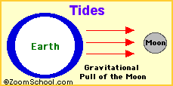
Tides are periodic rises and falls of large bodies of water. Tides are caused by the gravitational interaction between the Earth and the Moon. The gravitational attraction of the moon causes the oceans to bulge out in the direction of the moon. Another bulge occurs on the opposite side, since the Earth is also being pulled toward the moon (and away from the water on the far side). Since the earth is rotating while this is happening, two tides occur each day.
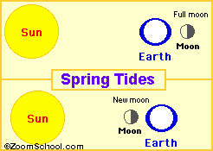

Spring tides are especially strong tides (they do not have anything to do with the season Spring). They occur when the Earth, the Sun, and the Moon are in a line. The gravitational forces of the Moon and the Sun both contribute to the tides. Spring tides occur during the full moon and the new moon.

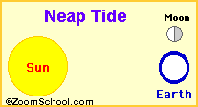
Neap tides are especially weak tides. They occur when the gravitational forces of the Moon and the Sun are perpendicular to one another (with respect to the Earth). Neap tides occur during quarter moons.
9.0.4 Sample Solutions (Teacher resource material)

- Sample screen shots of CBR data – Neap Tides vs Spring Tides
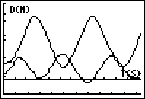
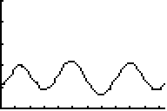

- Sample screen shots of List data

Porpoise Bay, B.C.
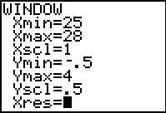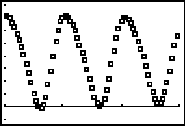

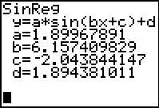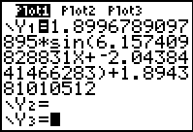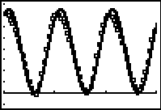

Glace Bay, N.S.
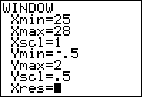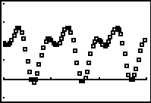

Bay of Fundy, N.S.
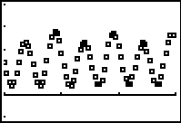

- Sample Solution for Day 1, BLM 9.1.2 #4

The scatter plot for the Bay of Fundy data could be modelled in parts using two sinusoidal functions. Horizontal translations of the two functions could be applied to predict unknown points.
9.0.4 Sample Solutions (Teacher resource material) (Continued)

- Sample Solutions for Day 2, BLM 9.2.3

Quadratic Function Model
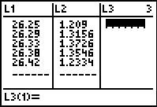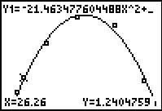

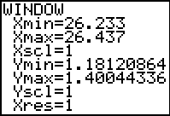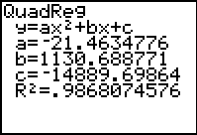

Exponential Function Model
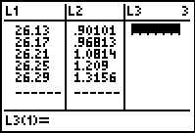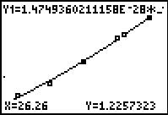

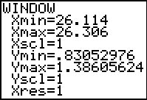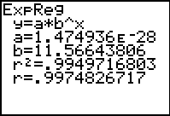

Trigonometric Function Model
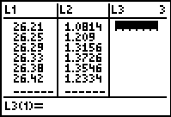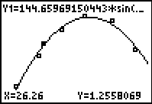

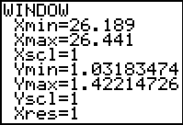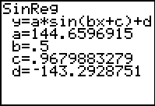
Students may use regression and the trace feature on a graphing calculator, or draw a curve of best fit and interpolate or extrapolate to predict unknown values.
9.0.4 Sample Solutions (Teacher resource material) (Continued)

 | Model 1 |  | Model 2 |  | Model 3 |  | Actual Data
Function | Quadratic |  | Exponential |  | Trigonometric |  | Value
Date Time | 26.29 | 26.33 | 26.29 | 26.33 | 26.29 | 26.33 | 26.29 | 26.33
Water Depth (m) | 1.324 | 1.375 | 1.319 | 1.455 | 1.325 | 1.366 | 1.316 | 1.373

  - The Water Depth, 1.319 m, for the exponential model is closer to the actual value, 1.316 m, for Date Time 26.29.
  - The Water Depth, 1.375 m, for the quadratic model is closer to the actual value, 1.373 m, for Date Time 26.33.
  - The regression exponential model has an r² value of 99.5 %.
  - The regression quadratic model has an r² value of 98.7 %.

Students may argue for whichever of their representative models best fits the data, giving examples to support their arguments. Their prediction for Date Time 26.26 depends on their most accurate model.

None of the models would be appropriate for predicting beyond Date Time 26.5. Although with the periodicity of the data, they may argue that other points on the scatter plot, that appear to fit transformations of their models, could be predicted.

By using regression and the trace feature on a graphing calculator, or a curve of best fit and interpolation or extrapolation, the students should determine two Date Times when the Water Depth reaches 1.2 m.

Real-world data is complex and requires sophisticated functions to model the data points. More than one model may fit the data. Accurate models are necessary to predict future trends. Predictions can be made for points close to the real data. As you get further away from the real data the models and the predictions become less accurate.

Unit 9 : Day 1 : Tidal Current Path |  |  |  | Grade 11 U/C
Minds On:  5 min |  | Assessment Goals  Students will:  - Demonstrate an understanding of periodic relationships and the sine function, and make connections between the numeric, graphical, and algebraic representations of the sine function (TFV.002)  - Identify and represent sine functions, and solve problems involving sine functions, including those arising from real-world applications (TFV.003) |  | Materials  - string/rope  - measuring tape  - CBR  - graphing calculators  - BLM 9.0.1  - BLM 9.0.2  - BLM 9.0.3  - BLM 9.1.1  - BLM 9.1.2  - BLM 9.1.3.8XI – 9.1.6.8XI (list data)  - BLM 9.1.7 (rubric)
Action: 65 min
Consolidate:
5 min
Assessment
Opportunities
 | Minds On… | Whole Class → Discussion  Remind students they may use BLM 9.0.1 or BLM 9.0.2 throughout the two days of the assessment.  Review the terms ebb current, flood current, spring tides and neap tides.  Instruct students to gather needed materials and move to assigned groups. |  |  | Note: It may save time if groups are assigned during the summative preparation.  Each student in the group will be responsible for recording the graphs as they will need this during individual evaluation.  Optional:  Students could copy pic1 and pic2 to their own graphing calculator using a link.  The data collected using the CBR today is not required for day 2 of the assessment.
 | Action! | Small Groups → Model Exploration  Students will make a hypothesis prior to activating the CBR as seen in BLM 9.1.1. Remind students that they may have multiple trials to get the graphs for each scenario. Save their best work as pic1 and pic2.  Students complete a walk of spring tides and neap tides using the CBR, a graphing calculator and BLM 9.1.1. They will store their  Store collected distance-time graphs.  Learning Skills/Teamwork/Observation/Checklist: Observe how well students work as a productive team to complete the task.  Individual → Assessment  Students will individually work through BLM 9.1.2 and submit at the end of the class.  Assessment: Teacher evaluates BLM 9.1.2 using a rubric BLM 9.1.7.
 | Consolidate Debrief | Whole Class ➔ Discussion  Start students thinking about tomorrow’s activity.  Why predict? (See lesson outline for Unit 9: Day 2).

Home Activity or Further Classroom Consolidation
Prepare for pencil and paper assessment.

9.1.1 Exploring the Tidal Current Path

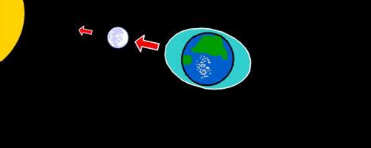
When the sun and moon are aligned, at the time of full moon or new moon, their gravitational forces act in the same direction and produce more pronounced high and low tides that are called spring tides.
(http://www.onr.navy.mil/Focus/ocean/motion/tides1.htm)

- Have one member of your group walk back and forth at a constant rate to model the tidal current (ebb current and flood current) for spring tides (see the diagram below). Do not collect data with the CBR at this point.

Spring Tide
Use a 2.5 m rope when walking a line between the earth and moon in front of the CBR.
Walk the tidal current path of 2.5 m.

Sun Earth New Moon
(CBR)

- Hypothesis: What type of function would best model the tidal current path for spring tides?

- Collect data using the CBR. Once your group is satisfied with the model, store this as PIC1 on your graphing calculator.

- From the screen, sketch the model your group has created. Label your axes and provide scales.
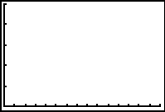

9.1.1 Tidal Current Path (continued)

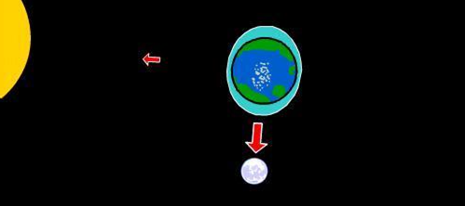
When the sun and moon are at right angles relative to the earth, the gravitational force of the sun partially cancels out the gravitational force of the moon. The result is less pronounced high and low tides that are called neap tides.
(http://www.onr.navy.mil/Focus/ocean/motion/tides1.htm)

Neap Tide
Use a 1.5 m rope when walking between the CBR and the moon.
Quarter Moon
Walk the tidal current path of 1.5 m.

Sun
Earth

(CBR)

- Hypothesis: What type of function would best model the tidal current path for neap tides?

- Collect data using the CBR. Once your group is satisfied with the model, store this as PIC2 on your graphing calculator.

- Sketch the function that models your walk for neap tides. Label your axes and provide scales

9.1.2 Modelling the Tidal Current Path

- Explain why the tidal current paths for neap tides and spring tides can be modelled with sinusoidal functions.

- Compare the two graphs that you have created using the CBR. Describe the similarities and the differences between the functions.

- Explain why the amplitudes for the two graphs are different. Refer to the real-world context in your explanation.

9.1.2 Modelling the Tidal Current Path (continued)

- The graph below shows the Water Depth vs. Date Time in the Bay of Fundy, Nova Scotia for three days, June 25 - June 27, 2006.

- Describe how you would use sinusoidal function(s) to model all or parts of the data.

- Explain how you would use your model(s) to predict water depth for a specified time.

This portion of the rubric considers BLM 9.1.1 Exploring the Tidal Current Path
THINKING
Reasoning and Proving
Criteria | Level 1 | Level 2 | Level 3 | Level 4
Formulation of hypotheses  #2 and #5 (BLM 9.1.1) | Forms hypotheses that connect a few aspects of the model | Forms hypotheses that connect some aspects of the model | Forms hypotheses that connect sufficient aspects of the model | Forms hypotheses that connect aspects of the model with a broader view of the model
The remainder of the rubric applies to BLM 9.1.2 Modelling the Tidal Current Path
THINKING
 |  | Reasoning and Proving
Criteria | Level 1 | Level 2 | Level 3 | Level 4
Degree of clarity in explanations and justifications  #1, #3, #4b | Explains and justifies in a way that is partially understandable | Explains and justifies so that the teacher understands, but would likely be unclear to others | Explains and justifies clearly for a range of audiences | Explains and justifies particularly clearly and with detail
Representing
Creation of a model to represent the data  #4a | Creates a model that represents little of the appropriate data | Creates a model that represents some of the appropriate data | Creates a model that represents most of the appropriate data | Creates a model that represents most of the appropriate data, accurately
APPLICATION
Connecting
Make connections among mathematical models  #2 | Makes weak connections | Makes simple connections | Makes appropriate connections | Makes strong connections
Relate mathematical ideas to situations drawn from other contexts  #3 | Makes weak connections | Makes simple connections | Makes appropriate connections | Makes strong connections
COMMUNICATION
Communicating #1 - 4
Ability to read and interpret mathematical language, charts, and graphs | Misinterprets a major part of the information, but carries on to make some otherwise reasonable statements | Misinterprets part of the information, but carries on to make some otherwise reasonable statements | Correctly interprets the information, and makes reasonable statements | Correctly interprets the information, and makes subtle or insightful statements
Correct use of mathematical symbols, labels, units and conventions | Sometimes uses mathematical symbols, labels and conventions correctly | Usually uses mathematical symbols, labels and conventions correctly | Consistently uses mathematical symbols, labels and conventions correctly | Consistently and meticulously uses mathematical symbols, labels and conventions
Appropriate use of mathematical vocabulary | Sometimes uses mathematical vocabulary correctly when expected | Usually uses mathematical vocabulary correctly when expected | Consistently uses mathematical vocabulary correctly when expected | Consistently uses mathematical vocabulary correctly, recognizing novel opportunities for its use

Unit 9 : Day 2 : Predicting from Tidal Current Data |  |  |  | Grade 11 U/C
Minds On:  5 min |  | Assessment Goals  Students will:  - predict, by extrapolating, the future behaviour of a relationship modelled using a numerical or graphical representation of a periodic function (TF2.02)  - distinguish exponential functions from linear and quadratic functions (EF 1.05)  - identify sine functions, including those that arise from real-world applications involving periodic phenomena and explain any restrictions that the context places on the domain and range(TF3.02) |  | Materials  - Graphing calculators  - BLM 9.1.3.8XI – 9.1.6.8XI (list data)  - Lists 1-4 entered in calculators (to allow ample time for modelling the data vs entering the data)  - Coloured writing utensils  - BLM 9.2.1  - BLM 9.2.2  - BLM 9.2.3  - BLM 9.2.4 (rubric)
Action: 65 min
Consolidate:
5 min
Assessment
Opportunities
 | Minds On… | Whole Class → Discussion  Recall from the preparation period and begin with discussion of the importance of monitoring the tides and their currents.  - Explain who would be interested in tidal shifts and how tides would affect them, e.g., commercial fishermen, coastal engineers, ecologists, atmospheric scientists  - Explain what effect tides would have on how to manoeuvre commercial ships  Instruct students to gather needed materials and move to assigned pairs. |  |  | ADT is Atlantic Daylight Savings Time  PDT is Pacific Daylight Savings Time  Optional:  Students could repeat the exploration for lists 3 and 4.  Graphs may be constructed by hand or using regression on a calculator. Predictions may be made using interpolation/ extrapolation or with the trace feature of the calculator.
 | Action! | In Pairs → Model Exploration  Students will use the data stored in lists 1 and 2 of their calculators and BLM 9.2.2 to construct a scatter plot and use a sinusoidal regression to find an equation.  Curriculum Expectations/Demonstration/Observation/Checklist: Observe what transformations of sinusoidal functions students recall.  Individual → Assessment  Students will select data from BLM 9.2.1 to individually work through BLM 9.2.3 and submit at the end of the class.  Assessment: Teacher evaluates BLM 9.2.3 using a rubric BLM 9.2.4.
 | Consolidate Debrief | Whole Class ➔ Discussion  Discuss the complexity of real-world data and the need for finding sophisticated models to represent the data. Explain how more than one model may be used to represent specific data, but also the need for accurate models from which to predict.

Home Activity or Further Classroom Consolidation
Prepare for pencil and paper assessment.

9.2.1 Tidal Current Data

Time Period  Daylight Savings Time (ADT/PDT) | June 2006 Date | 24 Hour Time | Date Time | Bay of Fundy, N.S.  Water Depth (m) | Glace Bay, N.S.  Water Depth (m) | Porpoise Bay, B.C.  Water Depth (m)
2006-06-25 00:00 | 25 | 0 | 25.00 | 0.727691 | 0.96422 | 3.590255
2006-06-25 01:00 | 25 | 1 | 25.04 | 0.457272 | 0.909713 | 3.567327
2006-06-25 02:00 | 25 | 2 | 25.08 | 0.2616 | 0.895906 | 3.460808
2006-06-25 03:00 | 25 | 3 | 25.13 | 0.189161 | 0.945453 | 3.303441
2006-06-25 04:00 | 25 | 4 | 25.17 | 0.259128 | 1.045923 | 3.099306
2006-06-25 05:00 | 25 | 5 | 25.21 | 0.448082 | 1.169335 | 2.855854
2006-06-25 06:00 | 25 | 6 | 25.25 | 0.698012 | 1.281082 | 2.59855
2006-06-25 07:00 | 25 | 7 | 25.29 | 0.938355 | 1.350087 | 2.331731
2006-06-25 08:00 | 25 | 8 | 25.33 | 1.105366 | 1.350727 | 2.02774
2006-06-25 09:00 | 25 | 9 | 25.38 | 1.155769 | 1.25158 | 1.678146
2006-06-25 10:00 | 25 | 10 | 25.42 | 1.078492 | 1.054542 | 1.306122
2006-06-25 11:00 | 25 | 11 | 25.46 | 0.898277 | 0.78512 | 0.926291
2006-06-25 12:00 | 25 | 12 | 25.50 | 0.664384 | 0.473439 | 0.548489
2006-06-25 13:00 | 25 | 13 | 25.54 | 0.433864 | 0.177931 | 0.216438
2006-06-25 14:00 | 25 | 14 | 25.58 | 0.262822 | -0.020739 | 0.002635
2006-06-25 15:00 | 25 | 15 | 25.63 | 0.201091 | -0.080765 | -0.037302
2006-06-25 16:00 | 25 | 16 | 25.67 | 0.277777 | -0.012852 | 0.104184
2006-06-25 17:00 | 25 | 17 | 25.71 | 0.48342 | 0.154177 | 0.404171
2006-06-25 18:00 | 25 | 18 | 25.75 | 0.768142 | 0.381203 | 0.843666
2006-06-25 19:00 | 25 | 19 | 25.79 | 1.059756 | 0.623156 | 1.391648
2006-06-25 20:00 | 25 | 20 | 25.83 | 1.286374 | 0.84099 | 1.974729
2006-06-25 21:00 | 25 | 21 | 25.88 | 1.392947 | 0.995921 | 2.514557
2006-06-25 22:00 | 25 | 22 | 25.92 | 1.35431 | 1.063037 | 2.972194
2006-06-25 23:00 | 25 | 23 | 25.96 | 1.183424 | 1.056057 | 3.321667
2006-06-26 00:00 | 26 | 0 | 26.00 | 0.925875 | 1.012196 | 3.527523
2006-06-26 01:00 | 26 | 1 | 26.04 | 0.642289 | 0.949181 | 3.579487
2006-06-26 02:00 | 26 | 2 | 26.08 | 0.393597 | 0.901548 | 3.512942
2006-06-26 03:00 | 26 | 3 | 26.13 | 0.23461 | 0.901007 | 3.377456
2006-06-26 04:00 | 26 | 4 | 26.17 | 0.204769 | 0.968126 | 3.197067
2006-06-26 05:00 | 26 | 5 | 26.21 | 0.311602 | 1.081352 | 2.969711
2006-06-26 06:00 | 26 | 6 | 26.25 | 0.52183 | 1.209022 | 2.704059
2006-06-26 07:00 | 26 | 7 | 26.29 | 0.772569 | 1.315579 | 2.425957
2006-06-26 08:00 | 26 | 8 | 26.33 | 0.99378 | 1.37263 | 2.135965
2006-06-26 09:00 | 26 | 9 | 26.38 | 1.126796 | 1.354565 | 1.80957
2006-06-26 10:00 | 26 | 10 | 26.42 | 1.137025 | 1.233373 | 1.449102
2006-06-26 11:00 | 26 | 11 | 26.46 | 1.023726 | 1.016975 | 1.083341
2006-06-26 12:00 | 26 | 12 | 26.50 | 0.820622 | 0.732101 | 0.727763

9.2.1 Tidal Current Data (continued)

Time Period  Daylight Savings Time (ADT/PDT) | June 2006 Date | 24 Hour Time | Date Time | Bay of Fundy, N.S.  Water Depth (m) | Glace Bay, N.S.  Water Depth (m) | Porpoise Bay, B.C.  Water Depth (m)
2006-06-26 13:00 | 26 | 13 | 26.54 | 0.582451 | 0.413465 | 0.396999
2006-06-26 14:00 | 26 | 14 | 26.58 | 0.367677 | 0.127801 | 0.138853
2006-06-26 15:00 | 26 | 15 | 26.63 | 0.229342 | -0.045195 | 0.019144
2006-06-26 16:00 | 26 | 16 | 26.67 | 0.209173 | -0.075335 | 0.075818
2006-06-26 17:00 | 26 | 17 | 26.71 | 0.324496 | 0.017786 | 0.297547
2006-06-26 18:00 | 26 | 18 | 26.75 | 0.554543 | 0.200653 | 0.651801
2006-06-26 19:00 | 26 | 19 | 26.79 | 0.84273 | 0.431805 | 1.116809
2006-06-26 20:00 | 26 | 20 | 26.83 | 1.116112 | 0.668271 | 1.657215
2006-06-26 21:00 | 26 | 21 | 26.88 | 1.307242 | 0.872974 | 2.199826
2006-06-26 22:00 | 26 | 22 | 26.92 | 1.369724 | 1.00797 | 2.678395
2006-06-26 23:00 | 26 | 23 | 26.96 | 1.289621 | 1.05299 | 3.067207
2006-06-27 00:00 | 27 | 0 | 27.00 | 1.090553 | 1.034375 | 3.346633
2006-06-27 01:00 | 27 | 1 | 27.04 | 0.824988 | 0.983282 | 3.488777
2006-06-27 02:00 | 27 | 2 | 27.08 | 0.555413 | 0.920312 | 3.494146
2006-06-27 03:00 | 27 | 3 | 27.13 | 0.339803 | 0.881798 | 3.402325
2006-06-27 04:00 | 27 | 4 | 27.17 | 0.225411 | 0.898864 | 3.255779
2006-06-27 05:00 | 27 | 5 | 27.21 | 0.240469 | 0.982625 | 3.066342
2006-06-27 06:00 | 27 | 6 | 27.25 | 0.380824 | 1.103372 | 2.825828
2006-06-27 07:00 | 27 | 7 | 27.29 | 0.605083 | 1.228272 | 2.545504
2006-06-27 08:00 | 27 | 8 | 27.33 | 0.847765 | 1.324102 | 2.252496
2006-06-27 09:00 | 27 | 9 | 27.38 | 1.041348 | 1.366176 | 1.945725
2006-06-27 10:00 | 27 | 10 | 27.42 | 1.134032 | 1.327612 | 1.606963
2006-06-27 11:00 | 27 | 11 | 27.46 | 1.101622 | 1.185673 | 1.250078
2006-06-27 12:00 | 27 | 12 | 27.50 | 0.954884 | 0.954393 | 0.908226
2006-06-27 13:00 | 27 | 13 | 27.54 | 0.736388 | 0.66395 | 0.596932
2006-06-27 14:00 | 27 | 14 | 27.58 | 0.504533 | 0.354724 | 0.333671
2006-06-27 15:00 | 27 | 15 | 27.63 | 0.316035 | 0.098731 | 0.16535
2006-06-27 16:00 | 27 | 16 | 27.67 | 0.217404 | -0.032612 | 0.145172
2006-06-27 17:00 | 27 | 17 | 27.71 | 0.239907 | -0.025119 | 0.289972
2006-06-27 18:00 | 27 | 18 | 27.75 | 0.388912 | 0.092839 | 0.570683
2006-06-27 19:00 | 27 | 19 | 27.79 | 0.63417 | 0.285661 | 0.949571
2006-06-27 20:00 | 27 | 20 | 27.83 | 0.915007 | 0.513078 | 1.40641
2006-06-27 21:00 | 27 | 21 | 27.88 | 1.160085 | 0.735684 | 1.905767
2006-06-27 22:00 | 27 | 22 | 27.92 | 1.308395 | 0.917692 | 2.380041
2006-06-27 23:00 | 27 | 23 | 27.96 | 1.323918 | 1.022546 | 2.778862

9.2.2 Why Predict Tides and Currents?

High Tide Low Tide
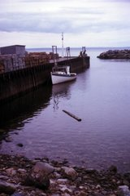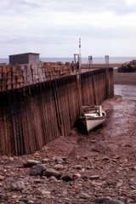

Lists 1 through 4 of your graphing calculator have tidal data for three locations in Canada over three days - June 25, 2006 through June 27, 2006.

List 1 contains Date Time

Note: The times in the table are in decimal form by date. A time of 25.71 refers to June 25 at 0.71 of a day. Therefore 0.71 × 24 = 17 refers to 17:00 h (5:00 p.m.).

List 2 contains the Water Depth, in metres, for Porpoise Bay, British Columbia.

List 3 contains the Water Depth, in metres, for Glace Bay, Nova Scotia.

List 4 contains the Water Depth, in metres, for the Bay of Fundy in Nova Scotia.

Today you will be exploring possible mathematical models to represent the data.

In Pairs
- Construct the scatter plot of Water Depth (m) vs. Date Time for Porpoise Bay on the graphing calculator using the window settings shown.

- Use the above information to label the axes.

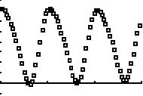

9.2.2 Why Predict Tides and Currents? (continued)

- Use a sinusoidal regression to find an equation in the form, W(t) = a*sin(bt + c) + d, that represents the Water Depth as a function of Date Time, t, for Porpoise Bay. Store this function in Y₁.
Record the equation below, rounding the values for a, b, c and d to the nearest hundred thousandth.

Your equation:
W(t) =

- Describe two transformations to the graph of W(t) = sin(t) to obtain the graph of the sine function representing Water Depth a function of Date Time, t, for Porpoise Bay.

- Is this trigonometric function an appropriate model for this data (check one)?

❒ yes or  no

Provide support for your choice.

The ability to predict tides and currents is essential for people who rely on the sea for their livelihood.

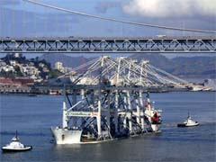
On June 14, 2002, these four marine cranes, each 220 feet tall and worth approximately $1.25 million, arrived in San Francisco Bay from Shanghai, China. Designed to rapidly hoist 40-foot-long containers from super-sized cargo ships, they had to be transported beneath the Oakland Bridge to reach their final destination, the Port of Oakland.

The tidal range of San Francisco Bay when these cranes were transported was 4.1 feet and the bridge had a motion of approximately 6 inches. With light chop on the bay and winds blowing at around 10 mph, there was little room for error. With detailed knowledge of the tidal cycle and skillful piloting of the vessel, the cranes cleared the bottom of the bridge by about 6 feet.

(http://www.nos.noaa.gov/education/kits/tides/media/supp_tide09a.html)

9.2.3 Predicting from Tidal Current Data

Examine the data for the Glace Bay tides in the scatter plot below of the Water Depth in metres to the Date Time.

- Identify sections of the data that could be modelled using linear, quadratic, exponential and trigonometric graphs. Use highlighters or coloured pencils to sketch your graphs on the scatter plot above and create a legend to keep track of your different function models.

- To accurately predict the Water Depth in metres for a Date Time of 26.26 (i.e., at 06:15 on the morning of June 26), use two different types of models from the following: quadratic, exponential and trigonometric. To graph your models, you will need to use at least 5 points between 00:00 ADT and 12:00 ADT on June 26 from the list of data for Glace Bay.

  - Below or on the following page, show your work and make your prediction for the Water Depth in metres at Date Time 26.26.

Model 1: Model 2:


Prediction: Prediction:

9.2.3 Predicting from Tidal Current Data (Continued)

Model 1: Prediction:
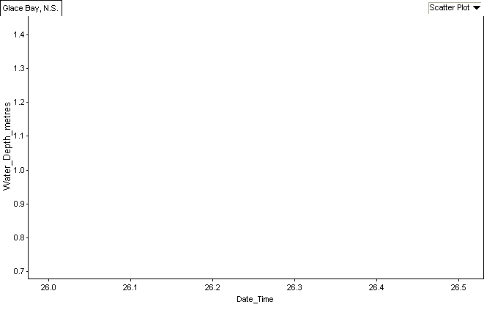

Model 2: Prediction:

9.2.3 Predicting from Tidal Current Data (Continued)

  - Use your function models to predict the Water Depths in metres for Date Times 26.29 and 26.33.

 | Model 1 |  | Model 2
Function
Date Time | 26.29 | 26.33 | 26.29 | 26.33
Water Depth (m)

  - Explain which of your function models is more accurate for predicting the Water Depth at the specified Date Time of 26.26. Use examples to justify your choice.

  - Explain whether your models would be appropriate for predicting the Water Depth for a Date Time beyond 26.5.

9.2.3 Predicting from Tidal Current Data (continued)

- At what Date Time(s) between 00:00 ADT and 12:00 ADT on June 26 was the Water Depth at 1.2 m? Show your work or explain the process that you followed.

- What conclusions would you make about selecting models to represent the data from various tide locations around the world?

Give reasons for your conclusions and make references to your:
  - initial hypothesis about modeling the ebb and flood of tidal currents on Day 1
  - explorations of the tidal current data from the Bay of Fundy, Glace Bay and Porpoise Bay on Days 1 and 2.
THINKING
Reasoning and Proving
Criteria | Level 1 | Level 2 | Level 3 | Level 4
Degree of clarity in explanations and justifications  #2c, #2d | Explains and justifies in a way that is partially understandable | Explains and justifies so that the teacher understands, but would likely be unclear to others | Explains and justifies clearly for a range of audiences | Explains and justifies particularly clearly and with detail
Making inferences,  conclusions and justifications  #4 | Justifies with a limited connection to the problem solving process and models presented | Justifies with some connection to the problem solving process and models presented | Justifies with a direct connection to the problem solving process and models presented | Justifies with a direct connection to the problem solving process and models presented, with evidence of reflection
Exploring and Reflecting
Ability to apply the processes of inquiry and problem solving, i.e., reflecting and revising and revisiting #2b, #2c | Applies the processes to the assigned task with significant prompts | Applies the processes to the assigned task with minor prompts | Applies the processes to the assigned task without prompts | Applies the processes to the assigned task with a broader view of the task without prompts
APPLICATION
Selecting Tools and Computational Strategies
Select and use appropriate tools and strategies to model the data, or solve a problem  #2a, #2b | Selects and applies appropriate tools, with major errors, omissions, or mis-sequencing | Selects and applies appropriate tools, with minor errors, omissions or mis-sequencing | Selects and applies appropriate tools, accurately, and logically sequenced | Selects and applies accurately and logically sequenced, using the most appropriate tools
Connecting
Makes connections among graphical models and context, and procedures  #1, #3 | Makes limited connections | Makes some connections | Makes most connections | Makes all possible connections
COMMUNICATION
Representing
Creation of graphical models to represent the data  #2 | Creates models that represent little of the appropriate data | Creates models that represent some of the appropriate data | Creates models that represent most of the appropriate data | Creates models that represent most of the appropriate data, accurately
Communicating #1-4
Ability to read and interpret mathematical language, charts, and graphs | Misinterprets a major part of the information, but carries on to make some otherwise reasonable statements | Misinterprets part of the information, but carries on to make some otherwise reasonable statements | Correctly interprets the information, and makes reasonable statements | Correctly interprets the information, and makes subtle or insightful statements
Correct use of mathematical symbols, labels, units and conventions | Sometimes uses mathematical symbols, labels and conventions correctly | Usually uses mathematical symbols, labels and conventions correctly | Consistently uses mathematical symbols, labels and conventions correctly | Consistently and meticulously uses mathematical symbols, labels and conventions
Appropriate use of mathematical vocabulary | Sometimes uses mathematical vocabulary correctly when expected | Usually uses mathematical vocabulary correctly when expected | Consistently uses mathematical vocabulary correctly when expected | Consistently uses mathematical vocabulary correctly, with novel uses

